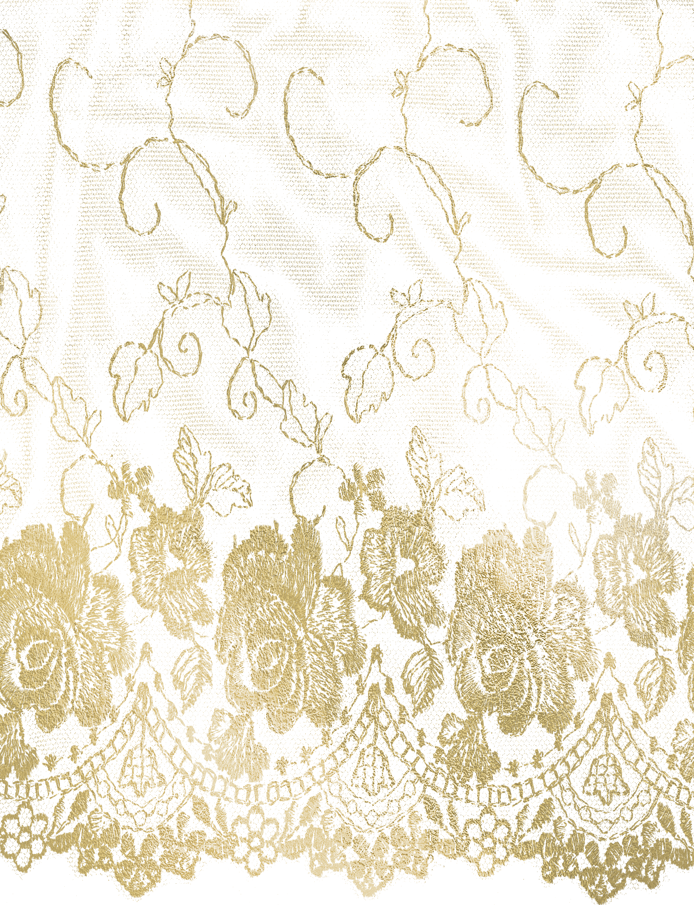
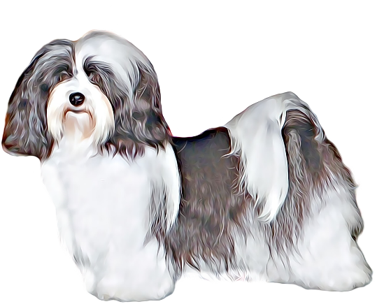

Exercise Pen
Wire Crate (17 X 24)
Crate pads for your crate
Wee Pads
Dry Food(Diamond Puppy Small Breed - Blue/White bag)
Shampoo/Conditioner
Wire Pin Brush
Canned Food (Caesars)
Stella and Chewy’s Dog Patties
Doggy Donut Bed
Toothbrush and paste
Ear Cleaner
Nail Clipper
Gatorade - Orange
Thermometer
Benadryl
Kids Immodium AD
Greyhound style comb
Happy Hips Jerky (glucosamine)
Food Bowls
Pigs Ears, Cow Hooves, Bully Sticks
Poochie Bells for Training
Relax and Calm by Tomlyn
Benebac or Propectillin
Saline

*I will Provide Harness and Leash and Toys from Here*

